JECRC 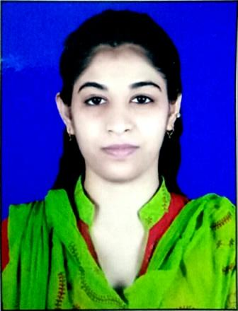
JAIPUR
INDIVIDUAL FACULTY DATA SHEET
Name of the faculty member | : | Nida Khanam
Present Designation | : | Assistant Professor
Email Id: nidakhanam.ce@jecrc.ac.in
Contact Details: 8741813384

I. Particulars of Educational Qualification: (only completed)

Category | Name of the Degree | Specialization | Year of Passing | Name of the College | Name of the University
UG | B.TECH | Civil engineering | 2015 | Jagannath University,jaipur | Jagannath University,jaipur
PG | - | - | - | - | -
Ph.D. | - | - | - | - | -

II. Academic Experience : 2 Year
III. Industrial Experience : Nil

IV. Title of Ph.D. Thesis : N.A.

V. Awards/Achievements : Nil

VI. Research/Specialization : Structure Engineering (pursuing)

VII. Course Taught : Civil engineering

VIII. Refereed International Journal Publication : Nil

IX. International Conference Proceeding : Nil

X. Books Written : Nil

XI. M.Tech Thesis Guide : Nil

XII. PHD Thesis Guide : Nil

XIII. Professional Body Membership : Nil

